Pinocchio, the Collection of 3D Natural Wood Puzzle
Pinocchio

3dino.eu and its Pinocchio project today offer you the opportunity to collect 2 gifts in one: a music box to mount and a secret book box to keep your personal belongings, your little secrets and your more nice memories. Each of our Pinocchio chimes also contains several other pieces to be set aside. By collecting all nine of Pinocchio's fable chimes, you will have the ability to build the latest and greatest 3d puzzle designed by 3dino.eu for your customers, the whale.
Having guarded all the parts you've found in the nine books, you can now relive the whole story of our famous wooden puppet, and be able to build the most moving part of the fairytale when Pinocchio and Geppetto meet again in whale stomach!
--------------------------------------------------------------------------------------------------------------------------
Pinocchio Collection: 9 Carillon + 9 Books + all the pieces to mount "The Whale"

€ 349,90
taxes included

Pinocchio Puzzle 3D Puzzle
in natural wood.

The Pinocchio Collection is an extraordinary gift idea
9 Books Box + 9 Musical Instruments + The Whale
Inside you find everything you need: screwdrivers and glue
Step-By-Step Instruction Manual Provided
All parts are produced in Natural Wood
A constructive activity that encourages ingenuity and skill

You can build all the most famous wood puppet adventures in the world and you will also be able to assemble the last great musical "La Balena" music box since you have collected all the pieces and parts you've found in the first nine volumes.
The full story of our wooden puppet is yours, you'll have 9 different book boxes and 9 different carillon plus of course the last "The Whale".
Sam and Alex, our engineers, have developed the project of the 3D whale puzzle with particular attention.
Two different mechanical movements are part of this project, but as we have written before, it must be a surprise for you.
By purchasing the entire collection at an affordable price, you can also consider the idea of ​​giving nine different people a carillon and giving them the chance to continue Pinocchio's story alone.
Pinocchio Collection is an extraordinary gift idea
9 Books Box + 9 Musical Instruments + The Whale
Inside you find everything you need: screwdrivers and glue
Step-By-Step Instruction Manual Provided
All parts are produced in Natural Wood
A constructive activity that encourages ingenuity and skill
Have fun also to mount the entire Pinocchio 3D Puzzle Collection, made of natural wood!

3dino.eu Puzzles are always made of high quality materials by thinking of children.

Product Safety:

This product is subject to specific warnings and safety instructions
Not suitable for children under 12 years of age
It is recommended to watch an adult

About this project
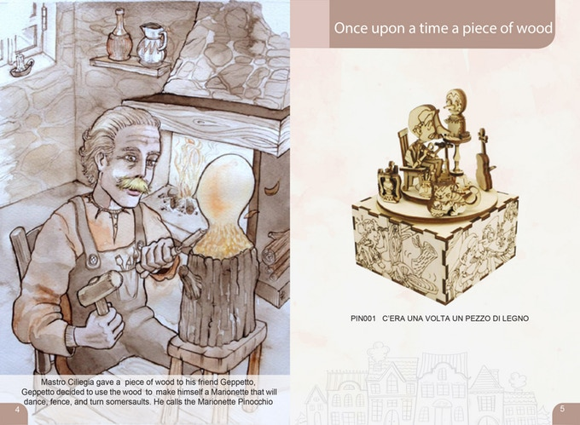PIN001

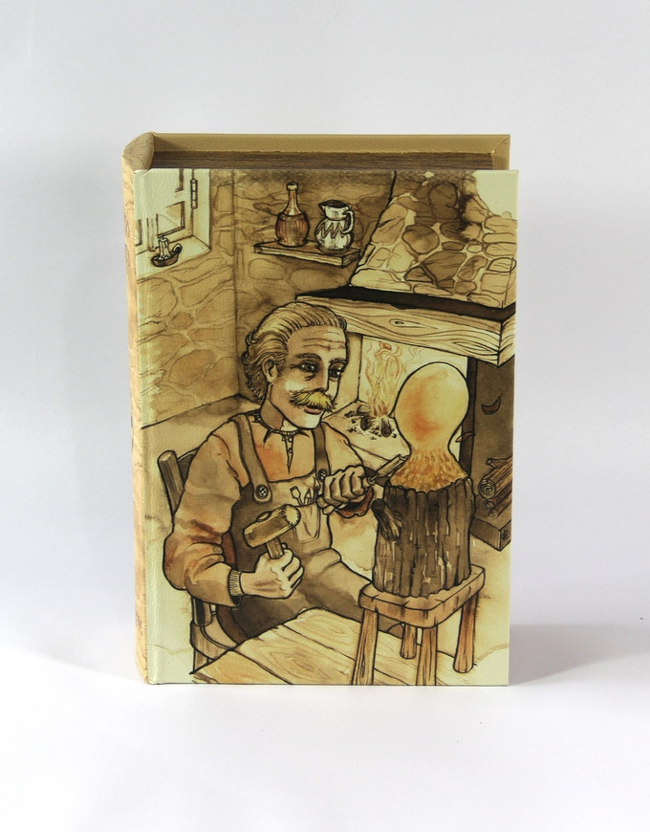PIN 001 first book to open and start building

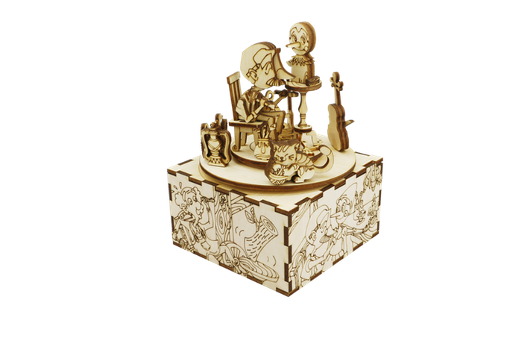MUSIC BOX NUMBER 1 FINISHED!!!
When I started to build 3 dimensional wooden puzzles in the past, I've often thought about how it would be nice to create something inspired by one of the most famous tales in the world.
I thought about the books I red in my life and, of course, Pinocchio jumped in my mind, since I'm Italian.
We decided that a 3 dimensional project (of course made of wood) was a great idea and we also thought that using a book as a packaging for our products, as showed in our video, https://vimeo.com/226876055 could be much more interesting for our potential customers. (the link above is in Italian)
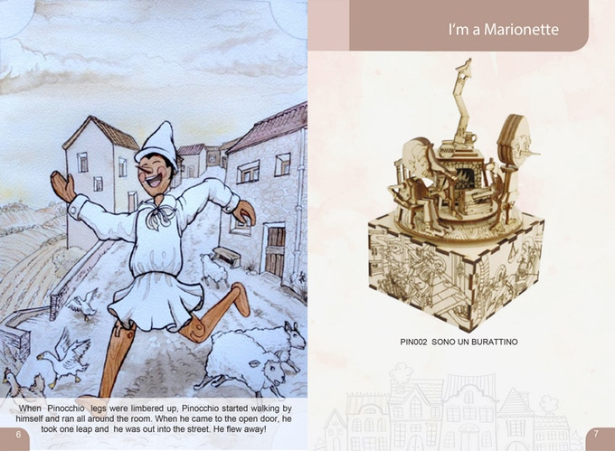PIN002

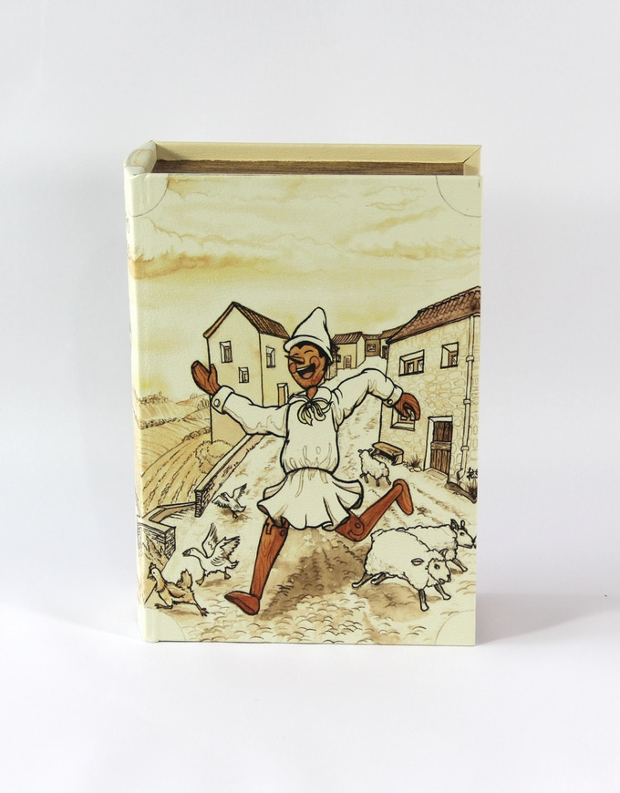PIN 002 Second book to open and start building!!!

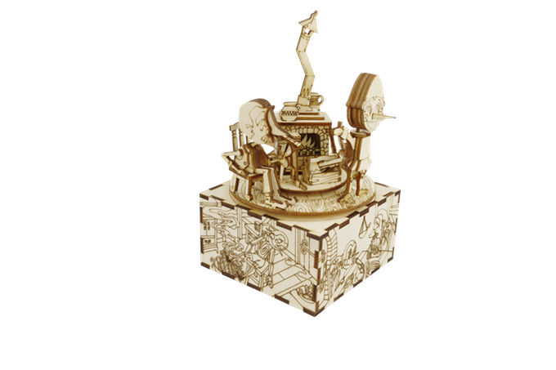MUSIC BOX NUMBER 2 FINISHED!!!
All these ideas, put together, became a real project that we started 18 months ago, and it's finally becoming real!!!!
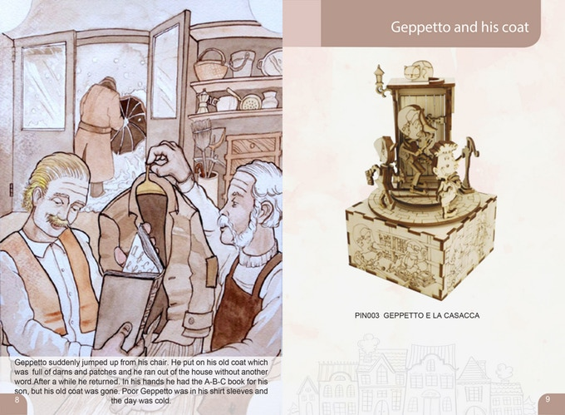PIN003

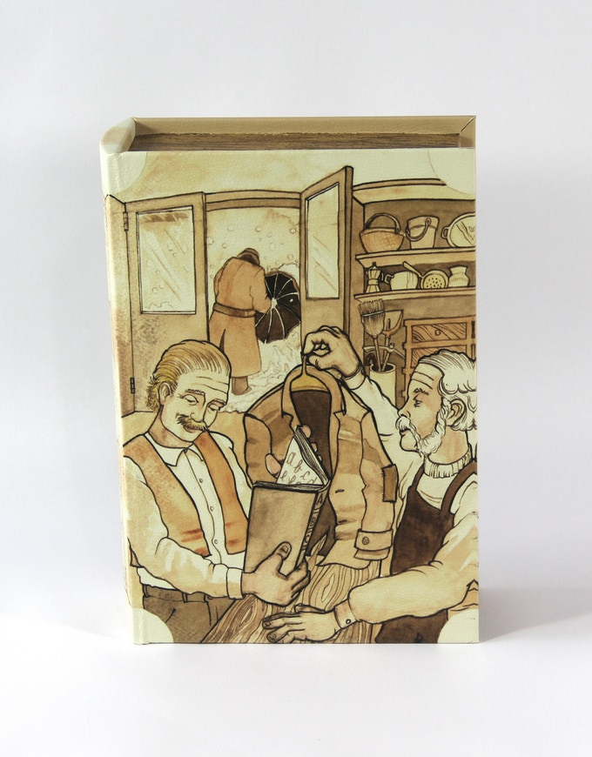PIN 003 Third book to open and start building!!!

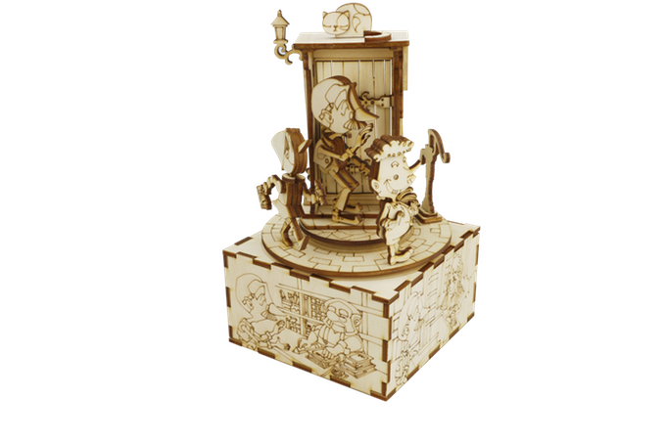MUSIC BOX NUMBER 3 FINISHED!!!
We are now giving the possibility to collect 2 gifts in one item: a music box and a secret box to keep your personal belongings or your favorite small items, like jewelery or keepsakes.
Each of our Pinocchio's music boxes, contains also several pieces to save. Collecting the nine music boxes, you'll have the chance to create and build the last one: "THE WHALE".
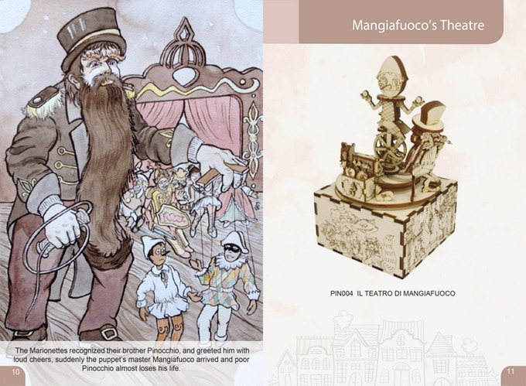PIN004

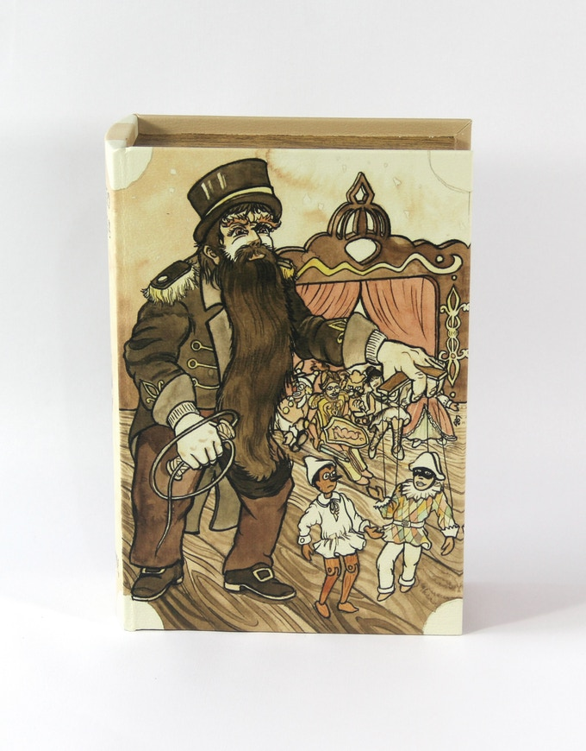PIN 004 fourth book to open and start building!!!

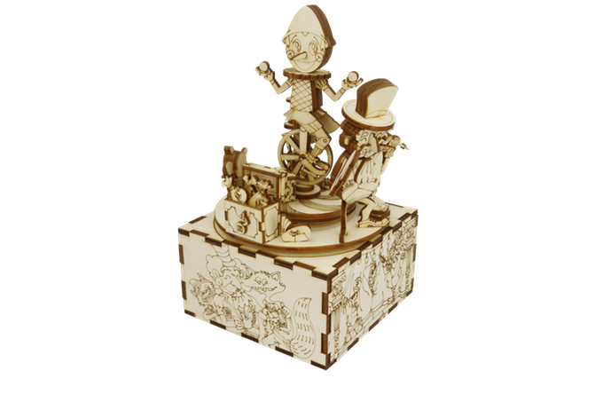MUSIC BOX NUMBER 4 FINISHED!!!
All the parts you found in the full collection, are now in your hands and you will be surprised by our last creation while you are building it.
Federico, our designer, drew all the pictures of the books while Sam and Alex, our engineers, created the 3 dimensional files and the project. The music box is composed of laser cut plywood like all the parts of the wooden puzzles.
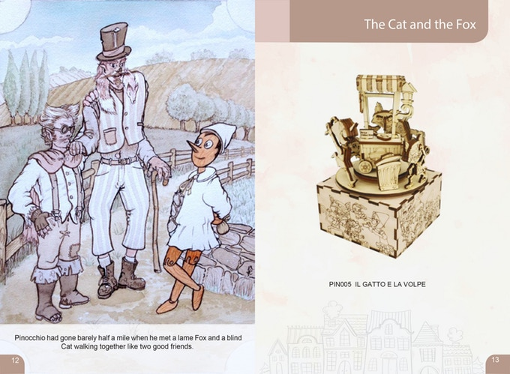PIN005

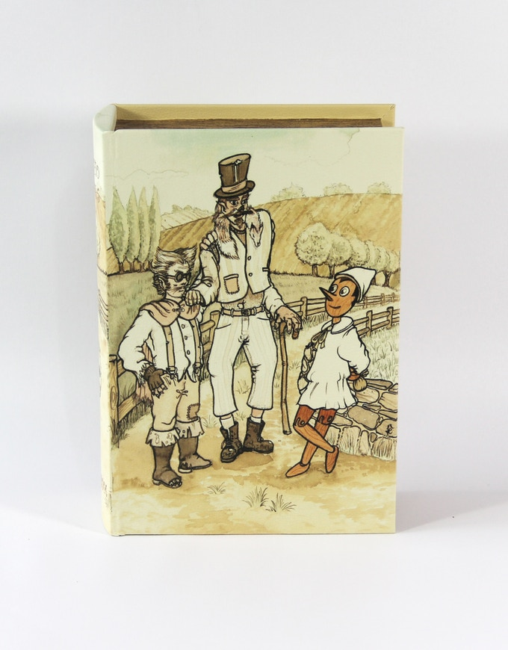PIN 005 fifth book to open and start building!!!

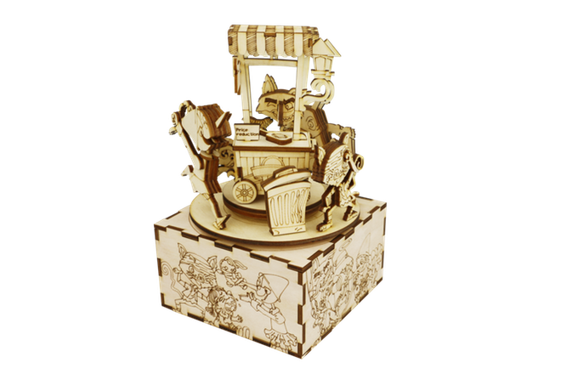MUSIC BOX NUMBER 5 FINISHED!!!
Lena helped us finding the right size of the books and we decided to cover them in ECO LEATHER, printed with Federico's drawings.

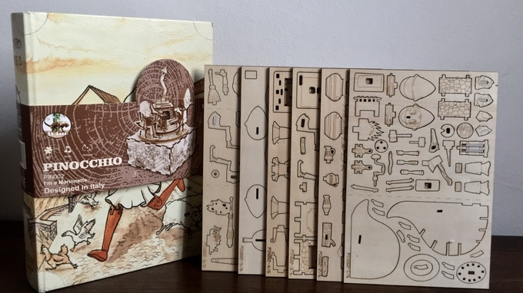THE SAMPLE OF THE BOOK AND WOODEN SHEETS
Maddalena, our graphic and video designer, just completed the video: we would love to send her our special gratitude for the amazing job she has done.
Each music box needs a lot of time to be drawn and cut. This long process influenced its cost.
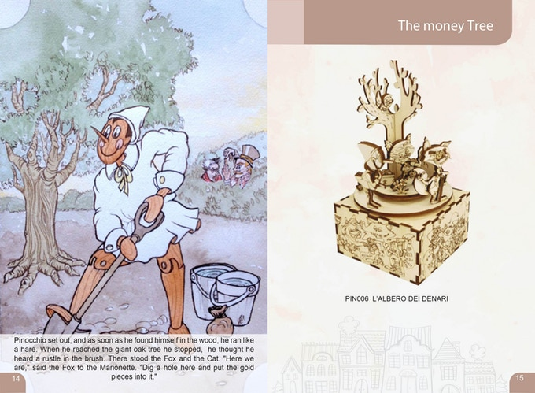PIN006

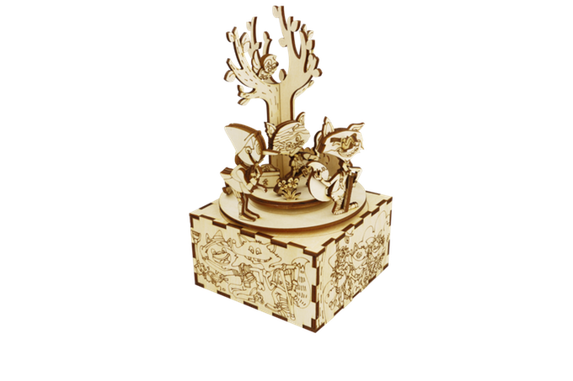PIN 006 sixth book to open and start building!!!
We couldn't support all this complicated and costly ideas by ourselves, so we asked for help from other factories collaborating with us in this project, and now to you, with our first Kickstarter campaign.
Vinny and his experience around the world helped us a lot.
In the past years, he used to work and import wooden items from all over the world, so he helped finding the suppliers we needed. He spent more than 18 months figuring out all details and best solutions for this project.
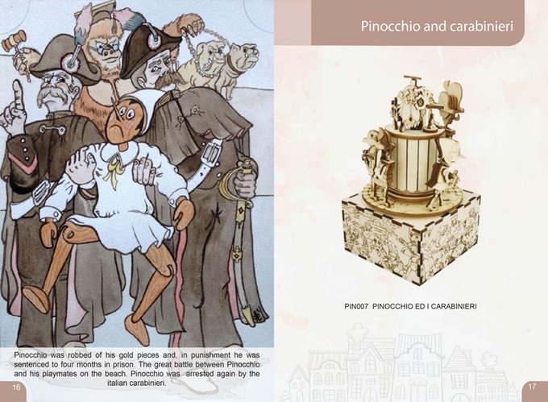PIN007

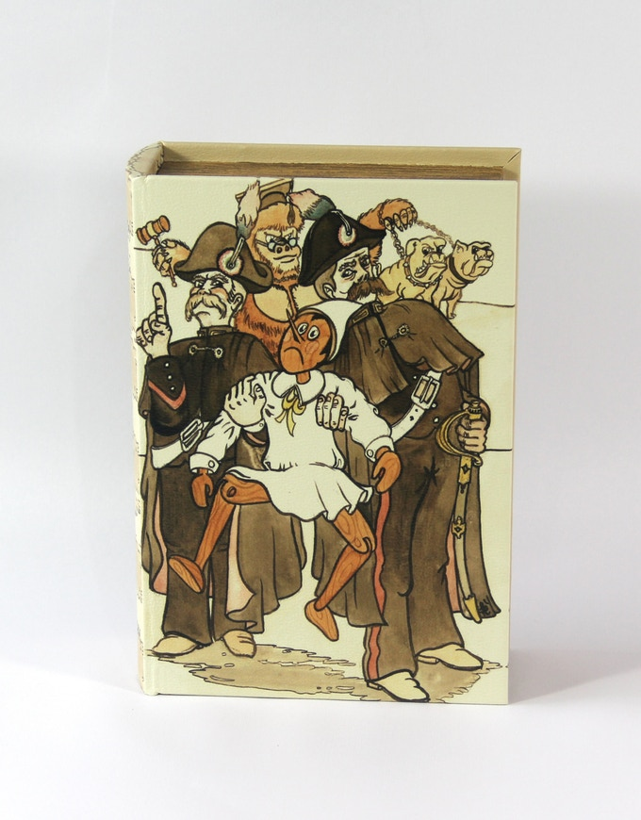PIN 007 seventh book to open and start building!!!

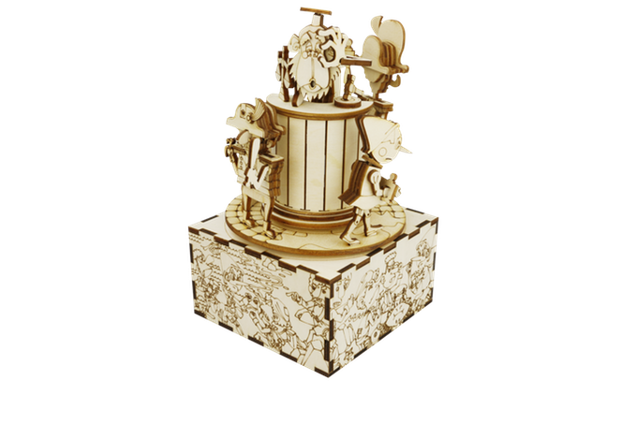MUSIC BOX NUMBER 7 FINISHED!!!
So, this is an original Italian design, unique in the world. Of course, some materials are imported, like plywood from Russia and music boxes from China, but I give you my word that you will get the best quality wooden puzzle to assemble, in your hands.
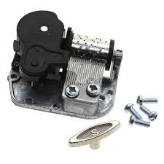NINE DIFFERENT MUSIC BOXES WITH DIFFERENT TUNES PLAYING
The art work was huge since all the characters of Pinocchio's tale are represented in our project, and maybe you would like to know a little more about the original story.
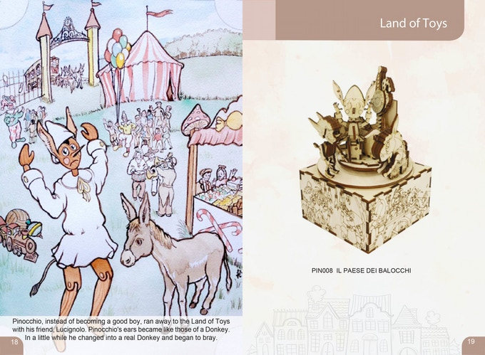PIN008

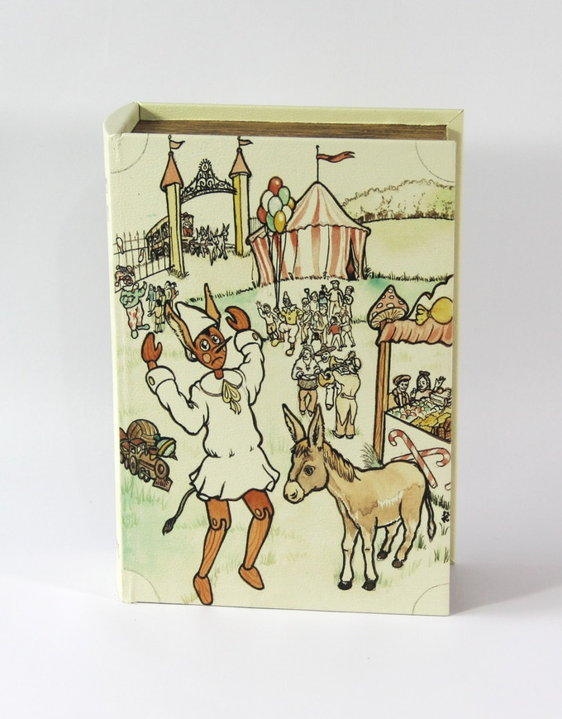PIN 008 eight book to open and start building!!!

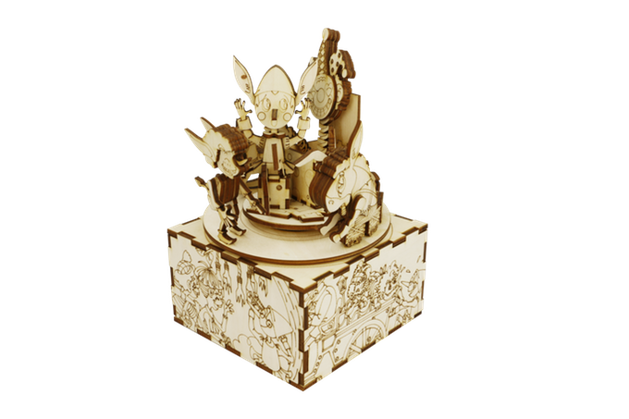MUSIC BOX NUMBER 8 FINISHED!!!
The Adventures of Pinocchio - in Italian: “Le avventure di Pinocchio” - is a children's novel written in Pescia by the Italian author Carlo Collodi. The first half was originally a serial published from 1881 to 1882, as “la storia di un burattino” (literally The Tale of a Marionette), and was completed as a children's book in February, 1883. It tells about the mischievous adventures of an animated marionette, named Pinocchio, and his father, a poor woodcarver named Geppetto.
It is considered a canonical piece of children's literature and has inspired hundreds of new editions, stage plays, merchandising, movies - such as Walt Disney's iconic animated version - and commonplaces, such as liars' long noses. According to an extensive research, made by the Fondazione Nazionale Carlo Collodi in late 1990s and based on UNESCO sources, it has been adapted in over 260 languages worldwide. That makes it the most translated non-religious book in the world, and one of the best-selling books ever published.
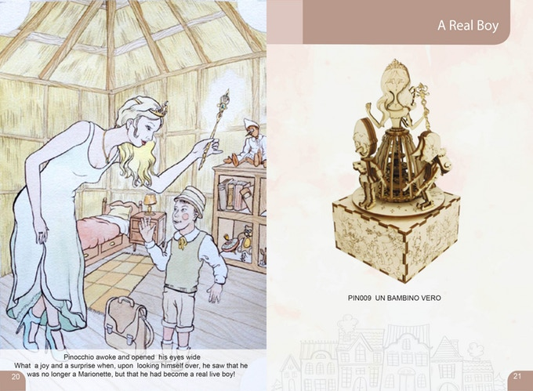PIN009

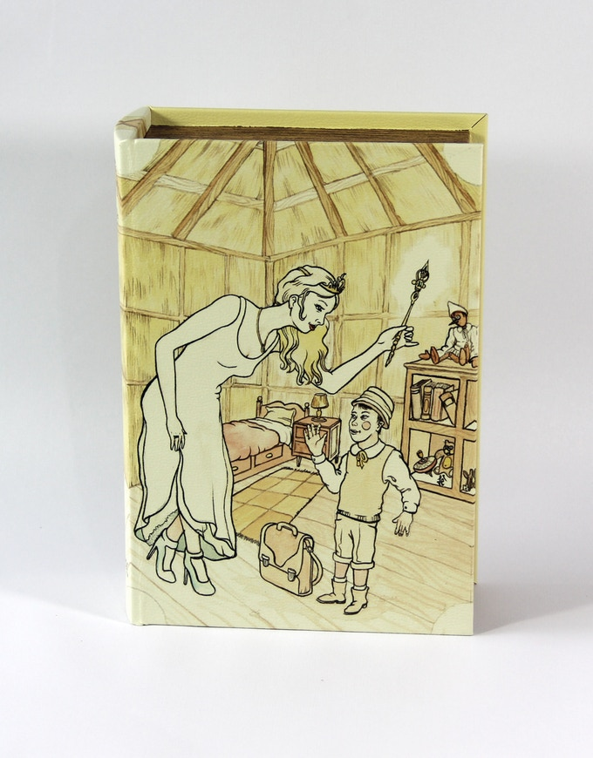PIN 009 nineth book to open and start building!!!

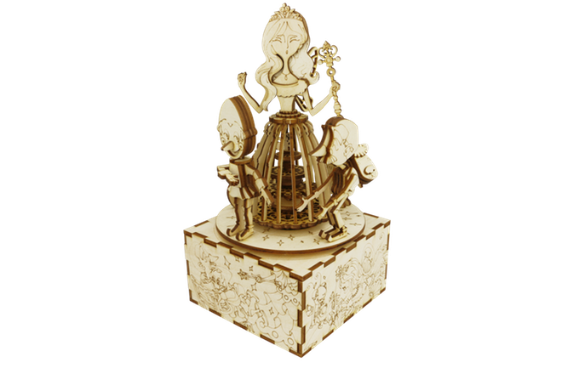MUSIC BOX NUMBER 9 FINISHED!!!
Each of the nine 3dino's music boxes has five wooden sheets of 3mm and one of 2 mm for small details. To build it, you need to use your imagination, glue if necessary, a little screw driver and, of course, you need to follow our instruction cards.
Removing step by step all the wooden pieces from the plywood sheets, you will be able to assemble your music box.
There are 9 different tunes that we've chosen, inspired by Pinocchio's Italian tale and our personal taste, and the metal music box system is included.
You just have to screw it to the right wooden piece while building your favorite episode of our wooden marionette story.
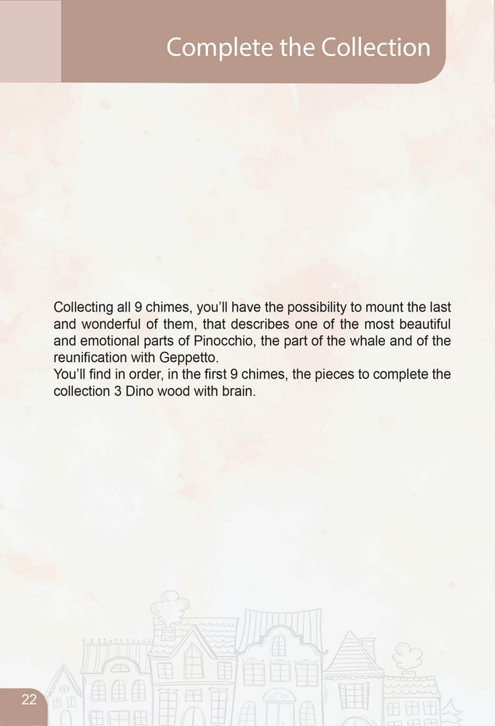
The final music box, that you can build only if you completed the full collection, is bigger and completely different from the others.
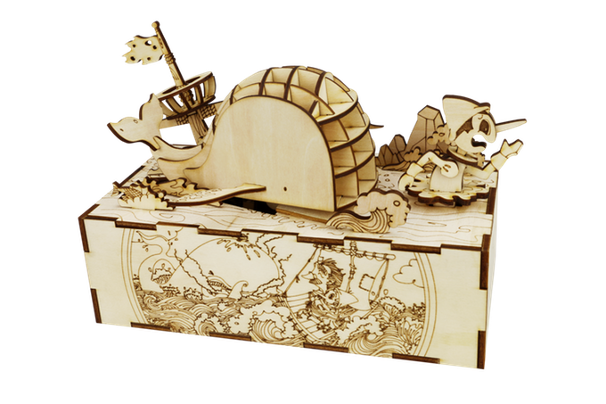COLLECT THEM ALL TO BUILD THE LASTONE!!!
This is a surprise for our customers!!!
We have chosen a competitive proposal for the entire collection, valid only during our campaign here on Kickstarter.
We are planning to create more famous tales that you will build yourself, but we need to be sure that our first idea is a good one!!!
We recommend these items from 12 years up!!!
Please, let us know your opinion and please support our first project here on Kickstarter!
Thank you for your help and don't hesitate to contact me if you have any questions.
3Dino Team

Risks and challenges
Pinocchio's music boxes project is 100% complete and we are finishing our first production.
We will be able to deliver all of them by mid October 2017.
We've chosen to deliver all over the world since October is a perfect time for Christmas presents.
We were waiting till the last minute to start our Kickstarter promotion because we wanted to give you a perfect and finished product and we are very proud of the final result.
At the end of the Kickstarter campaign, we will immediately start shipping all over the world and we'll concentrate on the next two projects.

